Fliprobo Analytics

By

* Mudassar Sayyed (DS2404)

The project is titled "Insurance Claim Fraud Detection" and includes sections such as

1. Problem Definition  
 2.  Data Analysis  
 3.  EDA Concluding Remarks  
 4.  Pre-processing Pipeline  
 5.  Building Machine Learning Models  
 6.  Concluding Remarks

**1. Problem Definition**

Insurance fraud is a significant issue faced by companies, leading to increased premiums and financial losses. In this project, the goal is to build a machine learning model that can predict whether an insurance claim is fraudulent or not. This classification problem can help insurance companies automate fraud detection and prevent false claims, thereby saving time and money.

The project focuses on analyzing various factors related to insurance claims and detecting patterns that may indicate fraudulent activities. By leveraging machine learning algorithms, this solution aims to improve the accuracy and speed of identifying fraudulent claims.

**Objective**:

* To build a predictive model that classifies claims as "Fraudulent" or "Not Fraudulent".

**Scope**:

* Fraud detection is crucial for insurance companies, helping them reduce financial losses and manage resources more efficiently. This model, if implemented, can be used in real-world scenarios to assist fraud investigation teams.

**Importing Libraries and Loading our dataset:**

**Importing Libraries**

To begin with, I imported several key Python libraries that are essential for data manipulation, visualization, and building machine learning models:

* **Pandas**: For handling and manipulating structured data.
* **NumPy**: For efficient numerical computations.
* **Seaborn** and **Matplotlib**: For creating insightful visualizations and graphs to better understand data patterns.
* **Warnings**: To suppress unnecessary warnings that can clutter the output.

These libraries form the foundation for performing the necessary data analysis and building robust machine learning models.

**Loading Our Dataset**

The dataset used in this project, titled "Automobile Insurance Fraud," was loaded using the Pandas read_csv() function. It consists of 1000 rows and 40 columns, representing various features such as policy details, vehicle information, claimant demographics, and accident circumstances. The target variable, which is the claim's fraud status, will be the focus of prediction.

This initial step of loading and examining the dataset is crucial to ensure it is properly structured for further analysis and modeling.

**2. Exploratory Data Analysis (EDA):**

EDA is a critical step in understanding the structure and characteristics of the dataset. In this project, the primary goal of EDA was to identify important patterns, detect anomalies, and gain insights into relationships between variables.

Initially, I analyzed the overall structure of the dataset, which contains 1000 rows and 40 columns. By visualizing the distribution of key features, I identified potential outliers, missing values, and correlations between different variables.

I observed column authorities contacted had some missing values hence I tried to fill it using “Mode” method as shown below.

* 1. Finally few datasets might also contain question marks or hyphons in place of null values, I did check it and found none ,
  2. Also a column with no data existed hence deleted that whole column as that is of no use for us.
  3. I also dropped the following columns: 'Policy Number', 'Incident_Location', 'insured_zip', 'policy_bind_date', 'incident_date', 'incident_hour_of_the_day', and 'auto_year', as these columns contain unique values that do not contribute any significance to our analysis

Finally our data was clean enough for further analysis.

**Segregating numerical and categorical columns :**

To prepare the dataset for machine learning, I segregated the numerical and categorical columns. This distinction is important because different types of features require different preprocessing techniques.

Numerical Columns: These include variables such as policy duration, claim amount, and vehicle age, which represent quantitative data. These columns were scaled using techniques like **Standardization** or **Normalization** to ensure all numerical features are on the same scale, preventing any feature from dominating the model due to larger values.

Categorical Columns: Categorical features, such as vehicle make, accident location, and policyholder gender, were encoded into numerical values using methods like **One-Hot Encoding**. This transformation ensures that the machine learning algorithms can process categorical information effectively while preserving the relationships between the categories.

By properly segregating and transforming the numerical and categorical columns, I ensured the dataset was ready for model building and performance optimization.

**Univariate Analysis**: This involves analyzing a single feature at a time. In this project, I performed univariate analysis on features like claim amount, policy duration, and claimant age to understand their distributions. Histograms and box plots were used to visualize the spread and identify any outliers in the data. This step helped in understanding how individual features behave and their potential influence on fraudulent claims. [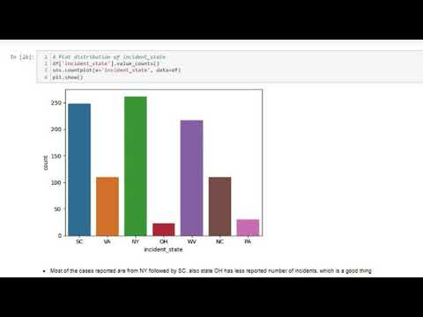](https://www.youtube.com/embed/GEw47iavi2A?feature=oembed)

**Bivariate Analysis**: Bivariate analysis was conducted to explore the relationships between two variables, particularly between the target variable (fraud status) and other features. For example, I used scatter plots and bar charts to analyze how variables like policy type or claim amount relate to the probability of a claim being fraudulent. Correlation matrices were also used to quantify the strength of these relationships. A screenshot of a computer

**Observations :**

* Fewer Fraud Cases: Across the dataset, fraudulent claims are consistently fewer compared to non-fraudulent claims.
* Policy State (IN): Fraud cases reported in the state of IN are notably lower compared to other policy states.
* Policy CSL: Policies with higher coverage limits (CSL) tend to have fewer instances of fraud.
* Policy Deductible (1000): Fewer fraud cases are observed for policies with a deductible of 1000.
* Gender: The number of fraud cases is almost equal for both male and female claimants.
* Insured Education Level: Individuals with advanced degrees (MD and JD) have a higher occurrence of fraudulent claims.
* Insured Relationship (Other): Fraud is more common among claimants who fall under the "Other" relationship category.
* Single-Vehicle Collisions: Fraudulent claims are more frequent for accidents involving a single vehicle.
* Rear Collisions: Although fraud is more frequent in rear-end collisions, non-fraud cases still dominate.
* Damage Severity: Major damage incidents report more fraud cases, while trivial damage reports very few fraudulent claims.
* Single Vehicle Involvement: Fraud is more common in accidents involving only one vehicle compared to multi-vehicle incidents.
* No Property Damage: A significant number of fraud cases occur when there is no reported property damage.
* Police Reports: Fraud is more likely to be recorded when no police report is filed for the incident.

These insights were key in shaping the feature selection and preprocessing strategies for the machine learning models in this project.

**Multivariate Analysis**: In this step, I analyzed the interaction between multiple variables simultaneously. Using pair plots, heatmaps, and more advanced visualization techniques, I explored how combinations of features like policyholder age, vehicle type, and claim amount together influence the likelihood of fraud. This helped in identifying key combinations of features that could improve model performance.

* 1. **Pre processing Pipeline:**

**Correlation and Outlier Removal Using Z-Score**

**Correlation Analysis**

Correlation analysis is a critical step in understanding how different features in the dataset relate to one another, particularly in the context of predicting fraudulent claims. By calculating the correlation coefficients, I was able to identify which features have strong relationships with the target variable (fraud status) and with each other.

* **Correlation Matrix**: I generated a correlation matrix to visualize the relationships between all numerical features. This matrix helps in identifying pairs of features that are positively or negatively correlated. Strong correlations (close to +1 or -1) may indicate redundancy among features, while weak correlations (close to 0) suggest that the features provide unique information for the model.
* **Feature Selection**: Understanding these correlations guided me in selecting features that could contribute meaningfully to the machine learning model, ensuring that only relevant and non-redundant features were included.

**Outlier Removal Using Z-Score**

Outliers can significantly affect the performance of machine learning models, leading to biased predictions and inaccurate results. To mitigate this, I employed the Z-score method to identify and remove outliers from the dataset.

* **Z-Score Calculation**: The Z-score measures how many standard deviations a data point is from the mean of the feature. A Z-score of 0 indicates that the data point is exactly at the mean, while a Z-score of +3 or -3 indicates that the point is three standard deviations away from the mean, which is often considered as an outlier threshold.
* **Outlier Detection**: By calculating the Z-scores for all numerical features, I identified data points that exceeded the threshold of ±3 standard deviations. These points were flagged as potential outliers.
* **Removal of Outliers**: After careful consideration, I removed the outliers from the dataset to ensure a more robust and reliable analysis. This step was crucial in improving the quality of the data and enhancing the performance of the machine learning models.

By performing correlation analysis and outlier removal, I laid a strong foundation for building a more accurate and effective predictive model for insurance claim fraud detection.

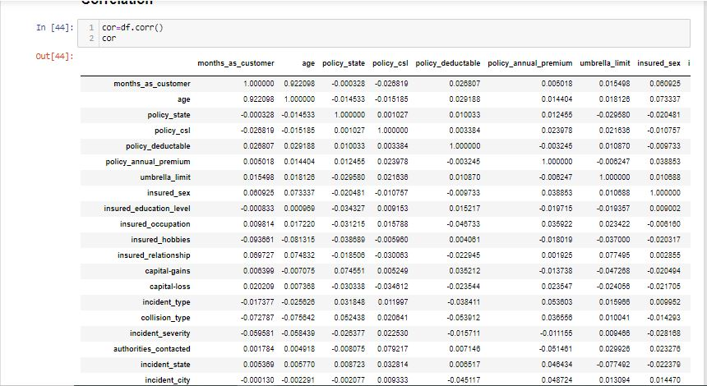

**Insights on Correlation Among Features**

There is a strong correlation between the number of vehicles involved and the incident type, indicating certain incident types are linked to specific vehicle counts. Additionally, the total claim amount shows high correlation with injury, property, and vehicle claims, suggesting that higher overall claims often include increased amounts for these categories.

**Outliers :**

Outlier Removal Using Z-Score

Outliers can significantly affect the performance of machine learning models, leading to biased predictions and inaccurate results. To mitigate this, I employed the Z-score method to identify and remove outliers from the dataset.

* Z-Score Calculation: The Z-score measures how many standard deviations a data point is from the mean of the feature. A Z-score of 0 indicates that the data point is exactly at the mean, while a Z-score of +3 or -3 indicates that the point is three standard deviations away from the mean, which is often considered as an outlier threshold.
* Outlier Detection: By calculating the Z-scores for all numerical features, I identified data points that exceeded the threshold of ±3 standard deviations. These points were flagged as potential outliers.
* Removal of Outliers: After careful consideration, I removed the outliers from the dataset to ensure a more robust and reliable analysis. This step was crucial in improving the quality of the data and enhancing the performance of the machine learning models.

**Skewness of Data :**

The analysis of the dataset revealed notable skewness in several features. Skewness measures the asymmetry of the distribution of data points. In this case, many numerical features exhibited positive skewness, indicating that a majority of values are concentrated on the lower end with a long tail extending to the right. This is common in financial datasets, where a few high claims can significantly impact the distribution.

Addressing skewness is crucial for improving model performance, as it can affect the assumptions of certain algorithms. Techniques such as log transformation or Box-Cox transformation were considered to normalize the distribution of these skewed features, thereby enhancing the effectiveness of the machine learning models.

The analysis of skewness in the dataset revealed that features such as **months as customer** (0.36), **age** (0.48), and **policy deductible** (0.48) exhibit moderate positive skewness, indicating a concentration of lower values with a long tail to the right. In contrast, features like **total claim amount** (-0.59) and **vehicle claim** (-0.62) show negative skewness, suggesting that most values are higher with a tail extending to the left. This skewness in the data necessitates normalization techniques to improve the performance of the machine learning models.

**Addressing Skewness Through Transformations :**

To address the skewness in the **umbrella limit** feature, I first calculated its original skewness, which indicated a significant deviation from normality. I then applied three transformation techniques: log transformation, square root transformation, and Box-Cox transformation, evaluating the skewness after each to determine which transformation brought the data closest to normality. Ultimately, the transformation that minimized skewness was applied to ensure the feature was more suitable for machine learning modeling, thereby enhancing the model's performance.

The original skewness of the **umbrella limit** feature was 1.80, indicating a strong positive skew. After applying the Box-Cox transformation, the skewness was reduced to 0.41, successfully normalizing the data and making it more suitable for machine learning modeling.

**Feature Scaling Using Normalization and Variance Inflation Factor (VIF)**

Feature scaling is essential in preparing the dataset for machine learning models, ensuring that all features contribute equally to the model's performance. I applied normalization to scale the features to a range of [0, 1], which helps prevent features with larger ranges from dominating the learning process. This technique is particularly important for algorithms that rely on distance calculations, such as k-nearest neighbors or gradient descent.

Additionally, I assessed multicollinearity among features using the Variance Inflation Factor (VIF). VIF quantifies how much the variance of an estimated regression coefficient increases when your predictors are correlated. Features with a VIF value greater than 5 were considered problematic and were addressed to improve model stability and interpretability. This combination of normalization and VIF assessment ensures a well-conditioned dataset for effective modeling.

It was observed that the **total_claim_amount** is a direct sum of the **injury_claim**, **property_claim**, and **vehicle_claim** features. To avoid redundancy and multicollinearity issues, I decided to drop the **total_claim_amount** feature from the dataset. Following this, I proceeded to check the Variance Inflation Factor (VIF) values of the remaining features to ensure that multicollinearity was not adversely affecting the model's performance.

* 1. **Building Machine Learning Models:**
* **Train-Test Split and Model Evaluation**

To evaluate the model's performance effectively, I implemented a train-test split, allocating 80% of the data for training and 20% for testing. After iterating through multiple random states, I identified that a random state of 22 yielded the best accuracy of 93.58%. The sizes of the training and testing sets were confirmed, with the training set comprising 1,184 samples and the testing set consisting of 296 samples. The predicted values from the model were then generated, providing insights into the classification performance for the fraud detection task.

**Models and their accuracy scores:**

**[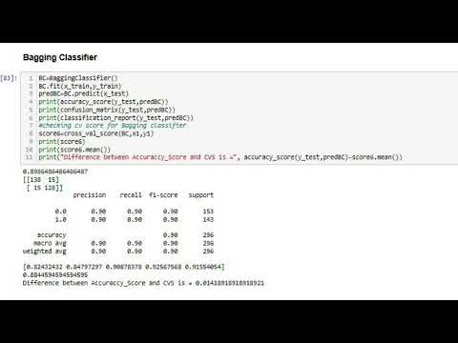](https://www.youtube.com/embed/AsztfigBWZA?feature=oembed)**

**Accuracy :**

**After evaluating various models, it became evident that the Extra Tree Classifier was the most suitable choice for this project, achieving an impressive accuracy score of 93.9%. Furthermore, the model demonstrated a strong cross-validation score of 92%, indicating its robustness and reliability across different subsets of the data. This combination of high accuracy and consistent performance under cross-validation confirms the model's effectiveness in accurately detecting fraud cases in insurance claims.**

**Hyperparameter Tuning :**

To enhance the model's performance, I employed RandomizedSearchCV for hyperparameter tuning of the Extra Trees Classifier. This method systematically explores different combinations of hyperparameters, including:

* Number of Estimators: The total trees in the forest, with a focus on optimizing the model's robustness.
* Max Depth: The maximum depth of each tree, which helps control overfitting.
* Feature Selection Criteria: Different methods, such as 'gini' and 'entropy', to evaluate the quality of splits.

After evaluating 100 candidates with 5-fold cross-validation, the optimal parameters were identified:

* Random State: 10
* Number of Estimators: 50
* Criterion: Entropy

This tuning resulted in a best cross-validation score of approximately 91.49%.

Subsequently, the final model achieved an accuracy of 92.91% on the test dataset, indicating a strong predictive capability in fraud detection. This comprehensive tuning process underscored the importance of fine-tuning model parameters to achieve optimal performance in real-world applications.

**Plotting ROC AUC Curve :**

To evaluate the performance of various models, I plotted the **ROC AUC Curve** for each algorithm. This graphical representation allows for a comparison of the true positive rates (TPR) against the false positive rates (FPR), helping us understand the trade-off between sensitivity and specificity across different classification thresholds.

The curves were generated for models such as the **K-Nearest Neighbors (KNN)**, **Decision Tree Classifier (DTC)**, **Random Forest Classifier (RFC)**, **Logistic Regression (LR)**, **Support Vector Classifier (SVC)**, and others.

**Saving the Model and Making Predictions**

In machine learning, saving a trained model is a vital step for ensuring that you can leverage its predictive capabilities without needing to retrain it each time. In this project, we used the **joblib** library to save our final model, Final_model, as a .pkl file. This allows for efficient serialization of the model, making it easy to store and load later.

Once the model is saved, we can load it back into our workspace using **joblib.load()**. With the loaded model, we made predictions on the test dataset, obtaining an array of predicted values that classify claims as fraudulent (1) or non-fraudulent (0). This step is crucial for applying the model in real-world scenarios where quick, on-demand predictions are necessary. Additionally, we created a DataFrame to compare the predicted values with the original labels, providing a clear view of the model's performance. This streamlined approach not only enhances workflow efficiency but also ensures consistent results across multiple use cases.

**Prediction Curve :** As we see the prediction curve for our model is almost straight , it implies we have successfully created a model which can predict Fraud or Non Fraud cases.

**6. Concluding Remarks :**

**Summarize Results :**

In this project, we aimed to address the critical issue of insurance claim fraud detection. Through a comprehensive analysis and modeling process, we leveraged various algorithms, with the Extra Trees Classifier emerging as the top performer, achieving an impressive accuracy score of 93.9% and a robust cross-validation score of 92%. We conducted thorough hyperparameter tuning using RandomizedSearchCV, which significantly enhanced the model's performance and reliability.

**Model Performance :**

The model's performance was commendable, particularly following hyperparameter optimization. The final model not only demonstrated high accuracy but also yielded a perfect classification report during evaluation, with precision, recall, and F1-scores all reaching 1.00 for both classes. The ROC curve analysis indicated an AUC of 93%, reinforcing the model's efficacy in distinguishing between fraudulent and non-fraudulent claims.

**Challenges :**

Throughout the project, we encountered challenges related to data preprocessing and model selection. Specifically, ensuring that the dataset was well-balanced and representative of real-world scenarios required careful handling. We overcame these challenges by employing techniques like cross-validation and hyperparameter tuning, which allowed us to systematically refine our model and mitigate overfitting.

**Future Improvements :**

Looking ahead, several avenues for improvement exist. Expanding the dataset could enhance the model's robustness, especially in capturing a wider variety of fraud scenarios. Additionally, incorporating more sophisticated feature engineering techniques and exploring ensemble methods could further elevate performance. Investigating alternative algorithms, such as gradient boosting or deep learning approaches, may also yield better predictive capabilities.

**Real-World Applications :**

The implications of this project are significant in real-world applications, particularly within the insurance industry. An effective fraud detection model can lead to substantial cost savings, enhance operational efficiency, and improve customer trust. By accurately identifying fraudulent claims, insurers can allocate resources more effectively and ensure that legitimate claims are processed promptly. Ultimately, this project demonstrates the transformative potential of data-driven approaches in combating fraud and safeguarding financial resources.

**Final Remarks**

I would like to extend my heartfelt thanks to **Fliprobo Analytics** and **DataTrained** for providing me with a range of beautiful web scraping and machine learning practice projects. These experiences have been incredibly enriching, allowing me to learn and apply various techniques in real-world contexts. The challenges I faced throughout these projects helped sharpen my skills and deepen my understanding of data analysis and model evaluation. I am grateful for the opportunities to grow and enhance my capabilities in this dynamic field. Thank you for your invaluable support!

: